**MS**

**PowerPoint**

**Class Five**

**Lab 19**

|  |
| --- |
| Lab Objectives:  * [Deleting Slides](http://www.electricteacher.com/pdeletes.htm) * [Moving Slides](http://www.electricteacher.com/pmoves.htm) * [PowerPoint Background](http://www.electricteacher.com/pviews.htm) |

# Deleting Slides

## Now that you've learned how to [add slides to a presentation](http://www.electricteacher.com/pslides.htm), the time has come to learn how to delete unwanted slides. Deleting slides can be performed in three ways. Select the slide and then

## Press the delete key on the keyboard

## Press the backspace key on the keyboard

## Right click on the slide and select Delete Slide

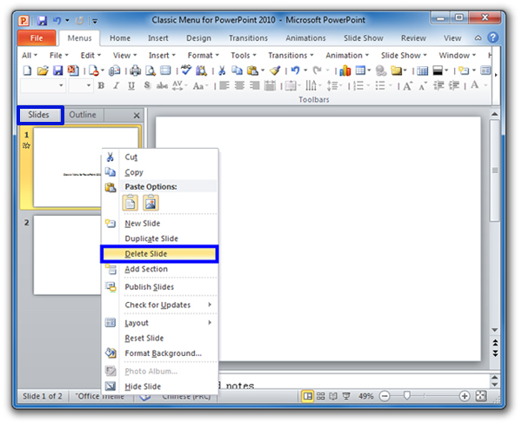

# Moving Slides

Suppose You see that slide 6 actually belongs before slide 5! What do you do, start again from scratch? There is no need. All you have to do is move the slide. You can change the sequence of your slides by moving them around your presentation.

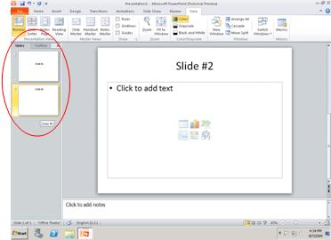

## To move a slide in your presentation, all you have to do is drag and drop it where you need it. As you drag the slide, you should see an insertion point that looks like either a horizontal or vertical line, depending on which PowerPoint view you are using, that tells you where your slide will appear.

# Moving Slides With Keyboard Shortcuts

## Another way to move slides around is to cut and paste them. Select the slide(s) you want to move and then right click > Cut. Select the slide that is positioned before where you want the slide to go and then right click > Paste. The slide(s) will appear after the selected slide. If you want to speed things up, you can use keyboard shortcuts: select the slide you want to move, press ctrl-x to cut it and then ctrl-v to paste it.

## Dragging and dropping your slides is probably the easiest method to use.



# Creating A PowerPoint Background

## For the background to your PowerPoint presentation, you can specify the following:

## A solid fill

## A gradient fill

## A picture or texture fill

## A Pattern fill

## To change your presentation background, click Design > Background > Background Styles > Format Background. Alternatively, you can right click on a free area on a slide (and area that doesn't contain an object) and then select Format Background from there.

## IMG_256You should now see the Format Background window.

## Ensure that the fill tab is selected (as in the image above) and then make changes according to what kind of background you want for your presentation.

# Solid Fill

## To specify a solid fill colour, ensure that the appropriate radio button is selected and then click on the Fill Colour swatch. A panel is displayed for you to select a colour.

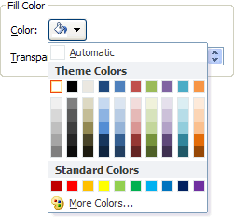

## The color in the main part of the grid are all theme color, so if you select one, you can be pretty confident that the background will blend in well with the rest of the presentation's color. At the bottom of the colour selection panel are standard color and if you want even more color to choose from, you can click More color at the bottom.

# Gradient Fill

## A gradient is the smooth transition of one colour into another.

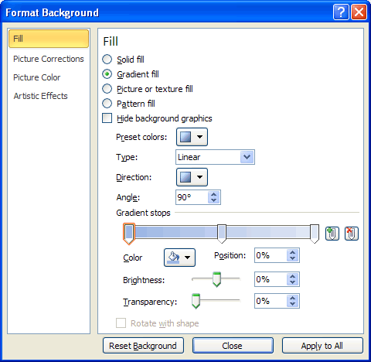

When this option is selected, you can choose from a selection of ready made gradients by clicking on the Preset color button. Alternatively, you can exercise more control by defining the gradient yourself.

If you do this, you will need to tell PowerPoint whether the gradient is linear, radial, rectangular, path or shade from title. Additionally you will need to specify the gradient direction, angle, where the color are positioned on the gradient (with the Gradient stops) and the properties of each colour in the gradient. These properties include what the colour is, how bright its is and also how transparent.

# Picture Or Texture Fill

## When specifying a picture or texture fill for your PowerPoint background, you are actually using a picture as the background.

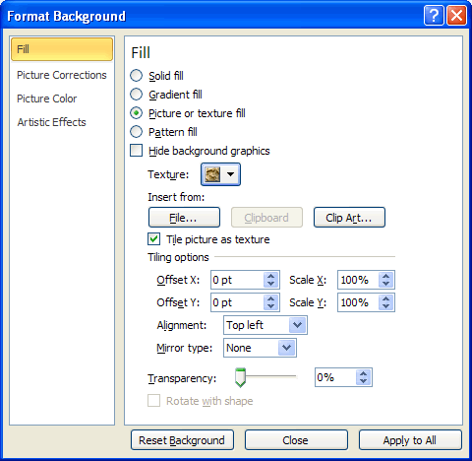

## PowerPoint comes with some built in textures you can use, or you can select an image that is stored on your hard drive. When you select an image in this way, you can choose to have the image appearing just once in the background, or to have it repeating like a texture. As you can see from the screenshot, there are many other attributes you can set that control the picture's appearance.

# Pattern Fill

## As with textures, PowerPoint ships with a selection of pre made patterns that you can use as your background.

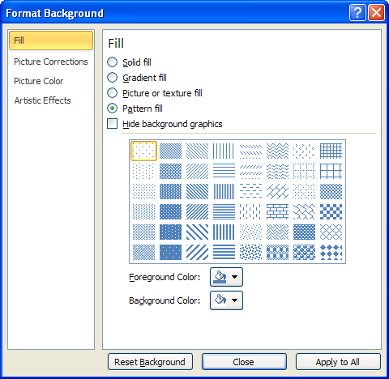

## Patterns available for selection include dots, stripes, zig zags, brickwork and many more. You can specify whatever foreground and background color you want to use.